Bahria University,

Karachi Campus



LAB EXPERIMENT NO.

___05___

LIST OF TASKS

|  |  |
| --- | --- |
| TASK NO | OBJECTIVE |
| **01** | Find the company’s name that placed order 10290. (Tables : Customers & Orders) |
| **02** | Find the Companies that placed orders in 1997 (Tables : Customers & Orders). |
| **03** | Create a report that shows the product name and supplier id for all products supplied by Exotic Liquids, Grandma Kelly's Homestead, and Tokyo Traders. (Tables : Products & Suppliers) |
| **04** | Create a report that shows all products by name that are in the Seafood category. |
| **05** | Create a report that shows all companies by name that sell products in CategoryID 8. |
| 06 | Create a report that shows all 5companies by name that sell products in the Seafood category. |
| 07 | Write query using a “sub query” to display which Customers were served by which Employee. |
| 08 | Write query using a “sub query” to list of all the stores that have discount records |
| 09 | Write query using a “sub query” to name publishers have got titles in store in Seattle? |
| 10 | Write query using a “sub query” to list all the authors available in Barnum’s store |
| 11 | Write query using a “sub query” to give the customer id and amount spent of the customer who spent the most |
| 12 | Write query using a “sub query” to list all Northwind customers who have not placed an order. |

Submitted On

29-03-2023

(Date: DD/MM/YY)

**Task 01:** Find the company’s name that placed order 10290. (Tables : Customers & Orders)

**Solution:** select CompanyName from Customers where CustomerID = (select CustomerID from Orders where OrderID=10290)

**Output:**

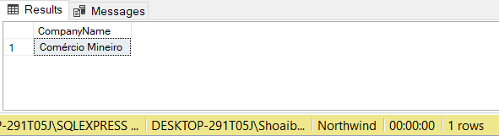

**Task 02:** Find the Companies that placed orders in 1997 (Tables : Customers & Orders).

**Solution:** select CompanyName from Customers where CustomerID in (select CustomerID from Orders where OrderDate >= '1997-01-01' and OrderDate <= '1997-12-31')

**Output:**

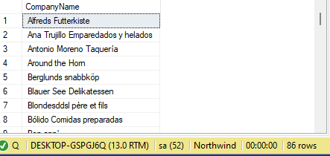

**Task 03:** Create a report that shows the product name and supplier id for all products supplied by Exotic Liquids, Grandma Kelly's Homestead, and Tokyo Traders. (Tables : Products & Suppliers)

HINT: You will need to escape the apostrophe in "Grandma Kelly's Homestead." To do so, place another apostrophe in front of it. For example,

SELECT * FROM Suppliers WHERE CompanyName='Grandma Kelly‘’s Homestead’;

**Solution:** select ProductName,SupplierID from Products where SupplierID in (select SupplierID from Suppliers where CompanyName in

( 'Tokyo Traders','Exotic Liquids','Grandma Kelly''s Homestead'))

**Output:**

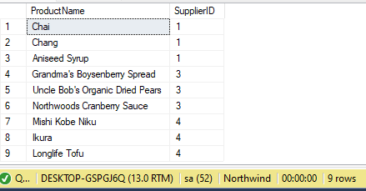

**Task 04:** Create a report that shows all products by name that are in the Seafood category. (Tables : Products & Categories)

**Solution:** select ProductName from Products where CategoryID = (select CategoryID from Categories where CategoryName='Seafood')

**Output:**

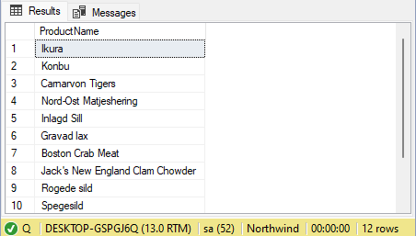

**Task 05:** Create a report that shows all companies by name that sell products in CategoryID 8. (Tables : Supplier & Products)

**Solution:** select CompanyName from Suppliers where SupplierID in (select SupplierID from Products where CategoryID='8')

**Output:**

**Task 06:** Create a report that shows all 5 companies by name that sell products in the Seafood category.(Tables: Suppliers, Products & Categories)

**Solution:** select CompanyName from Suppliers where SupplierID in (select SupplierID from Products where CategoryID = (select CategoryID from Categories where CategoryName='Seafood'))

**Output:**

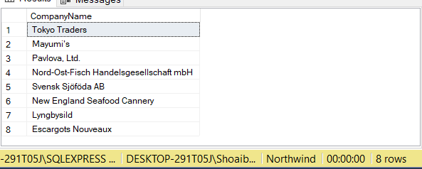

**Task 07:** Write query using a “sub query” to display which Customers were served by which Employee use Northwind

**Solution:** SELECT c.ContactName, e.FirstName +LastName as FullName FROM Customers c JOIN Orders o ON c.CustomerID = o.CustomerID JOIN Employees e ON o.EmployeeID = e.EmployeeID WHERE e.EmployeeID IN ( SELECT EmployeeID FROM Orders WHERE CustomerID = c.CustomerID);

**Output:**

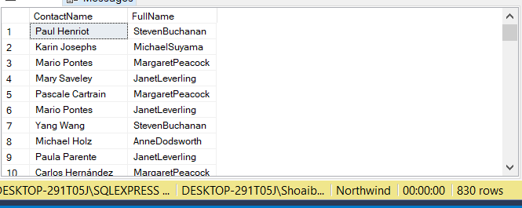

**Task 08:** Write query using a “sub query” to list of all the stores that have discount records use pubs

**Solution:** select stor_id,stor_name from stores where stor_id in (select stor_id from discounts)

**Output:**

**Task 09**: Write query using a “sub query” to name publishers have got titles in store in Seattle? Use pubs

**Solution:** select pub_id,pub_name from publishers where pub_id in (select pub_id from titles where title_id in (select title_id from sales where stor_id in (select stor_id from stores where city ='Seattle')))

**Output:**

**Task 10:** Write query using a “sub query” to list all the authors available in Barnum’s store use pubs

**Solution:** select (au_fname +' '+ au_lname) as FullName from authors where au_id in (select au_id from titleauthor where title_id in (select title_id from sales where stor_id in (select stor_id from stores where stor_name like 'Bar%' )))

**Output:**

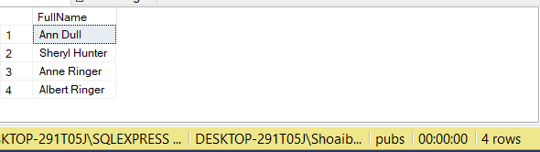

**Task 11:** Write query using a “sub query” to give the customer id and amount spent of the customer who spent the most using Northwind

**Solution:** select CustomerID,max(Quantity*UnitPrice) as [Highest Price] from Customers,[Order Details]

where CustomerID in (select CustomerID from Orders where OrderID in (select OrderID from[Order Details] WHERE UnitPrice*Quantity in (select MAX(UnitPrice*Quantity)from [Order Details]))) group by CustomerID

**Output:**

**Task 12:** Write query using a “sub query” to list all Northwind customers who have not placed an order.

**Solution:** select CustomerID , ContactName from Customers except (select CustomerID , ContactName from Customers where CustomerID in (select CustomerID from Orders))

**Output:**